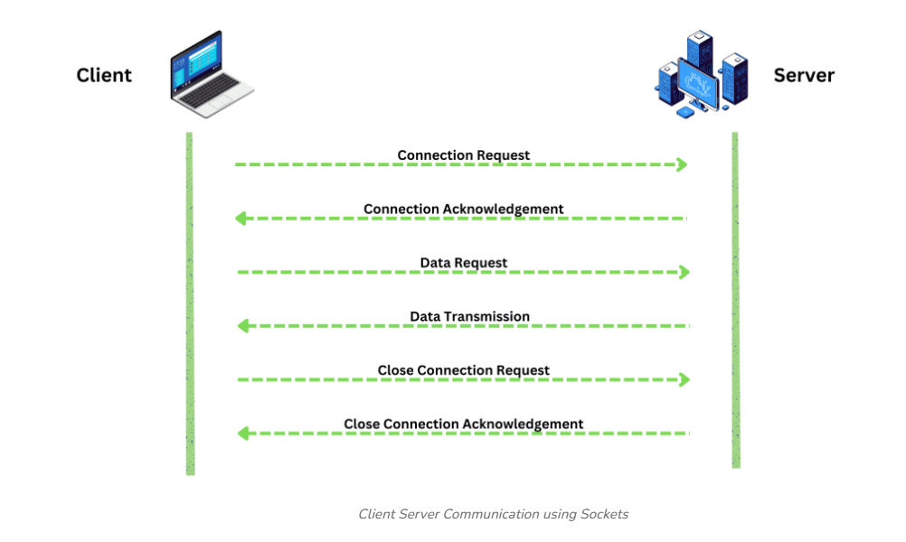

Client-Server Communication Flow
The Client-Server model is the foundation of the modern internet. It is a distributed application structure that partitions tasks or workloads between the providers of a resource or service (servers) and service requesters (clients).

1. The Request Phase (Client)
Everything starts when the user interacts with the browser (the Client).
- Action: The user enters a URL (e.g., https://www.example.com).
- DNS Lookup: The browser contacts a DNS server to translate the domain name into an IP Address.
- HTTP Request: The client sends an HTTP Request packet. This packet contains:
  - Method: (GET to retrieve data, POST to send data).
  - Headers: Information about the browser type and cookies.
  - Body: Data sent by the user (only in POST/PUT requests).

2. The Processing Phase (Server)
The Server is a high-powered computer waiting for requests. Once it receives the packet:
- Parsing: It reads the request to understand what the client needs.
- Application Logic: The server-side code (Node.js, Python, PHP, etc.) runs the necessary logic.
- Data Retrieval: If needed, the server communicates with a Database to fetch or store user information.

3. The Response Phase (Server to Client)
Once the server has the result, it sends back an HTTP Response:
- Status Code: A 3-digit number indicating the result (200 for success, 404 for not found, 500 for server error).
- Content-Type: Tells the browser what is being sent (e.g., text/html, image/png, or application/json).
- Response Body: The actual HTML, CSS, and JavaScript files that make up the webpage.

Summary Table for Assignment
Stage | Entity | Description
Request | Client | Browser sends a formatted message asking for a resource.
Transmission | Internet | Data is broken into packets and sent via TCP/IP protocol.
Processing | Server | The server executes code and queries the database.
Response | Server | The server sends back the requested files and a status code.
Rendering | Client | The browser interprets the HTML/CSS/JS and displays the page.

